1. Agenda:
   1. Disadvantage of using Basic Authentication.
2. **Disadvantages**  
   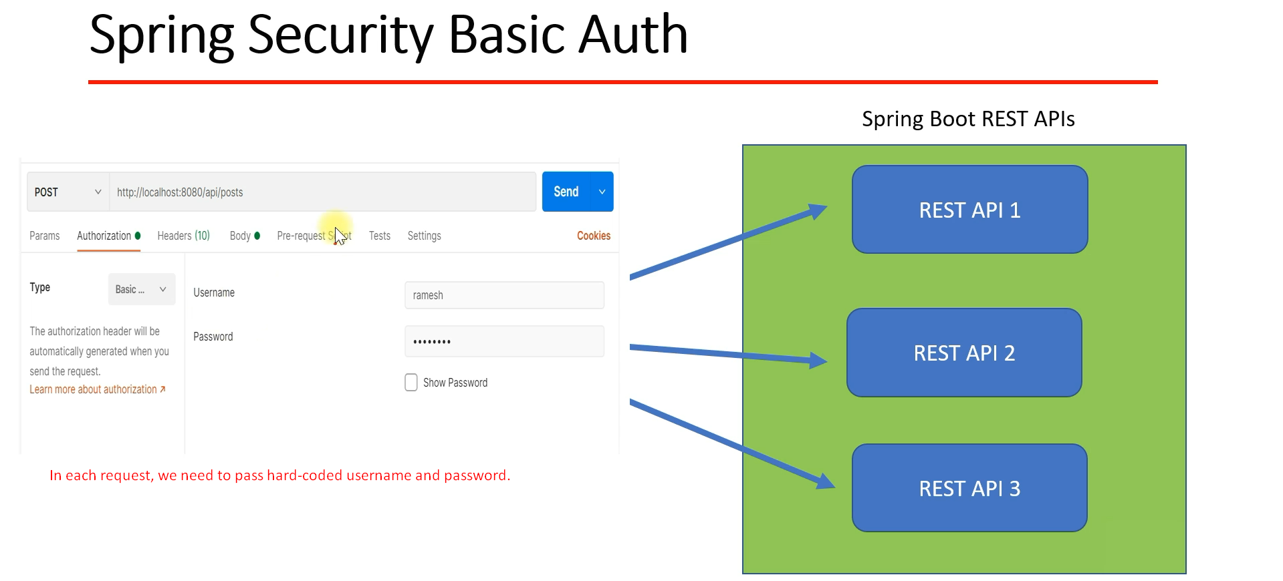
3. In case of JWT  
   